**Circuit Diagram:**

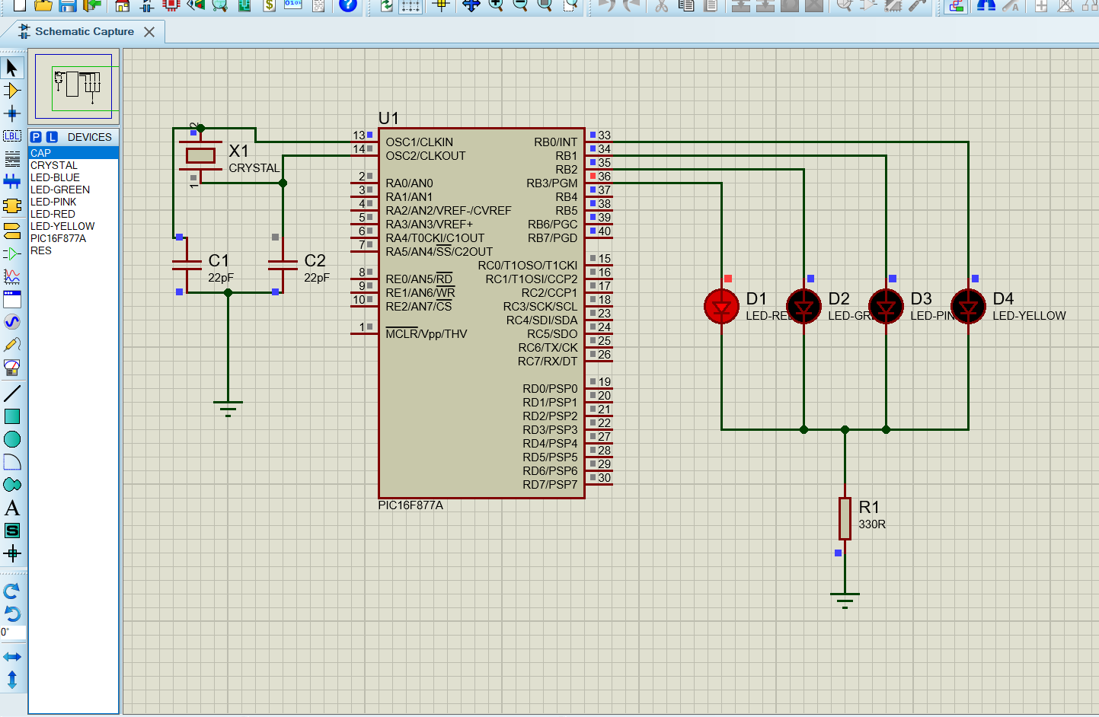

**Fig: LED Blinking**

**Code:**

int counter = 0;

void main() {

TRISB = 0x00;

PORTB = 0x00;

while(1)

{

PORTB.RB3 = 1;

Delay_ms(300);

PORTB.RB3 = 0;

PORTB.RB2 = 1;

Delay_ms(300);

PORTB.RB2 = 0;

PORTB.RB1 = 1;

Delay_ms(300);

PORTB.RB1 = 0;

PORTB.RB0 = 1;

Delay_ms(300);

PORTB.RB0 = 0;

counter++;

}

}

**Circuit Diagram:**

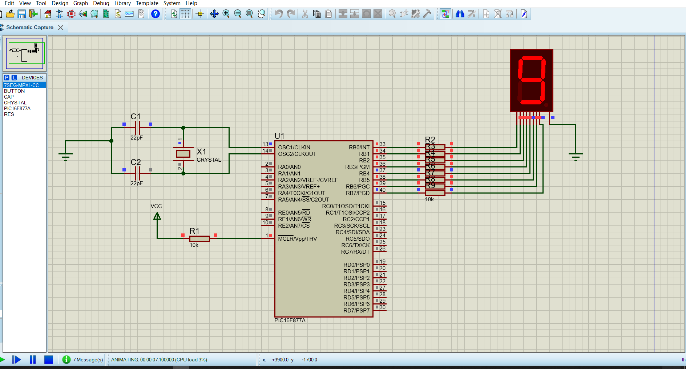

**Fig: 7Segment 1Digit Display**

**Code:**

char arraycc[]={0x3F,0x06,0x5B,0x4F,0x66,0x6D,0x7D,0x07,0x7F,0x6F};

void main() {

int i = 0;

trisb = 0x00;

portb = 0xff;

for(i=0; i<10; i++){

portb = arraycc[i];

delay_ms(100);

}

}

**Circuit Diagram:**

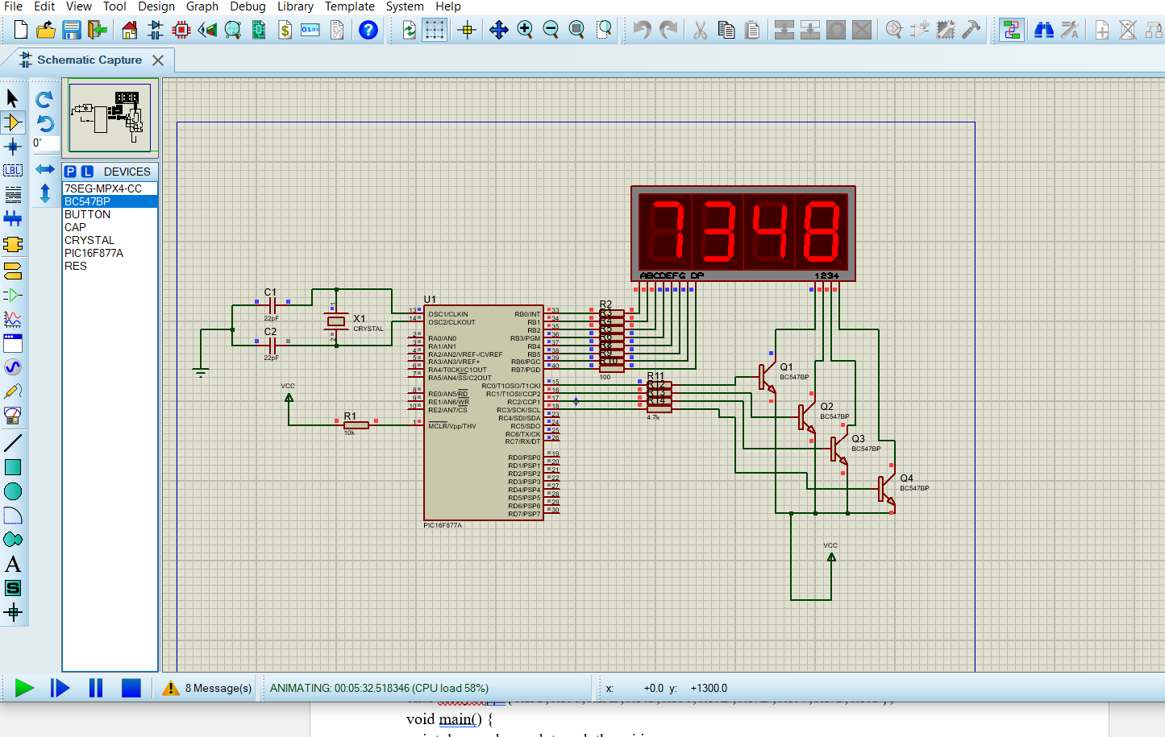

**Fig: 7-Segment 4Digit Display**

CODE:

char arraycc[]={0x3F,0x06,0x5B,0x4F,0x66,0x6D,0x7D,0x07,0x7F,0x6F};

void main() {

int d_zero,d_one,d_two,d_three,i,j;

Trisb=0x00;

Trisc=0x00;

portb=0x00;

portc=0x00;

while(1)

{

for(i=0;i<=9999;i++) //counting 0-9999

{

d_zero=i/1000; // for first digit of display

d_one=((i/100)%10); // for second digit

d_two=((i/10)%10); // for third digit

d_three=i%10;

for(j=0;j<=10;j++)

{

portc.f0=0;

portb=arraycc[d_zero];//display

delay_ms(1);

portc.f0=1;

portc.f1=0;

portb=arraycc[d_one];//display

delay_ms(1);

portc.f1=1;

portc.f2=0;

portb=arraycc[d_two];//display

delay_ms(1);

portc.f2=1;

portc.f3=0;

portb=arraycc[d_three];//display

delay_ms(1);

portc.f3=1;

}

}

}

}

**Circuit Diagram:**

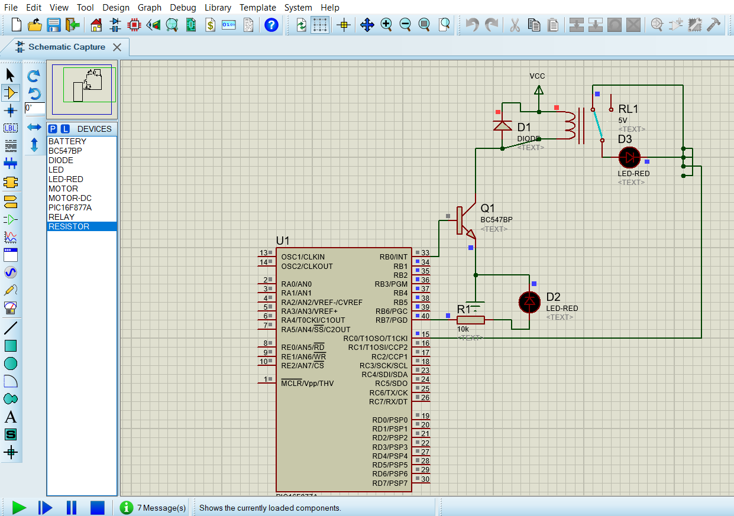

**Fig: control AC current by DC current.**

CODE:

void main() {

trisb=0;

portb=0;

while(1){

portb.f0=1;

delay_ms(1000);

portb.f0=0;

delay_ms(1000);

}

}

**Circuit Diagram:**

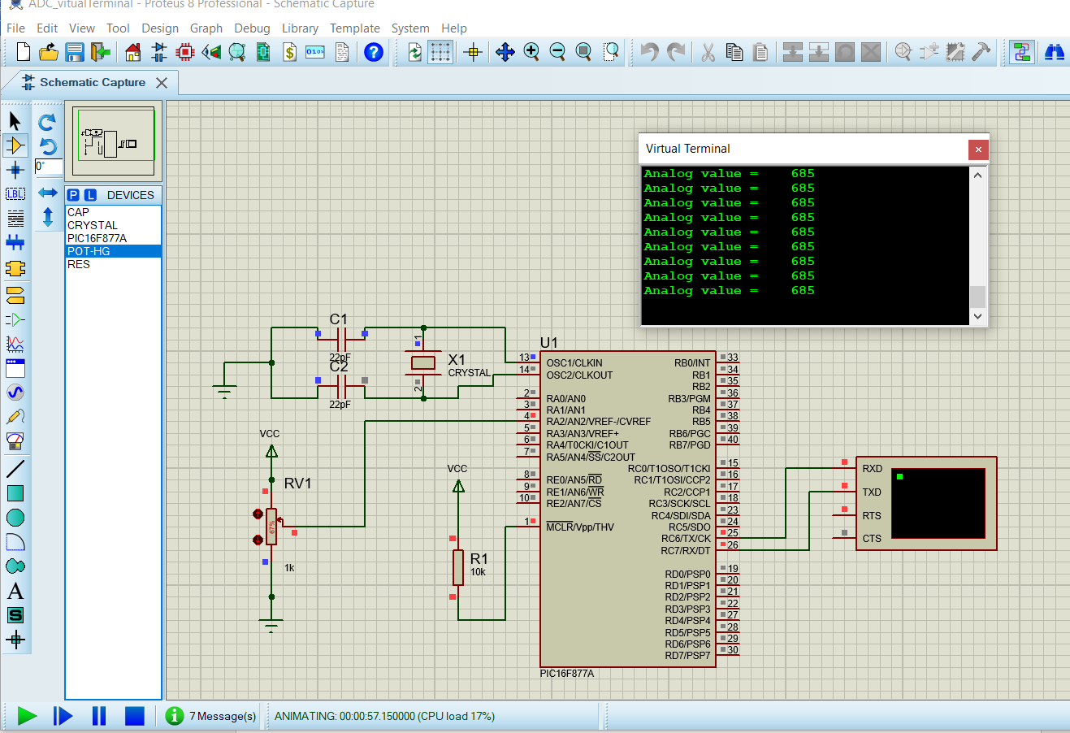

**Fig: Display ADC value in the virtual terminal.**

**CODE:**

int valADC;

char x[4];

void main(){

UART1_Init(9600);//initialize ADC

ADC_Init();

while(1){

valADC = ADC_Read(2);

IntToStr(valADC,x);

UART1_Write_Text("Analog value = ");

UART1_Write_Text(x);

strcpy(x,"");

UART1_Write(13);

Delay_ms(1000);

}

}

**Circuit Diagram:**

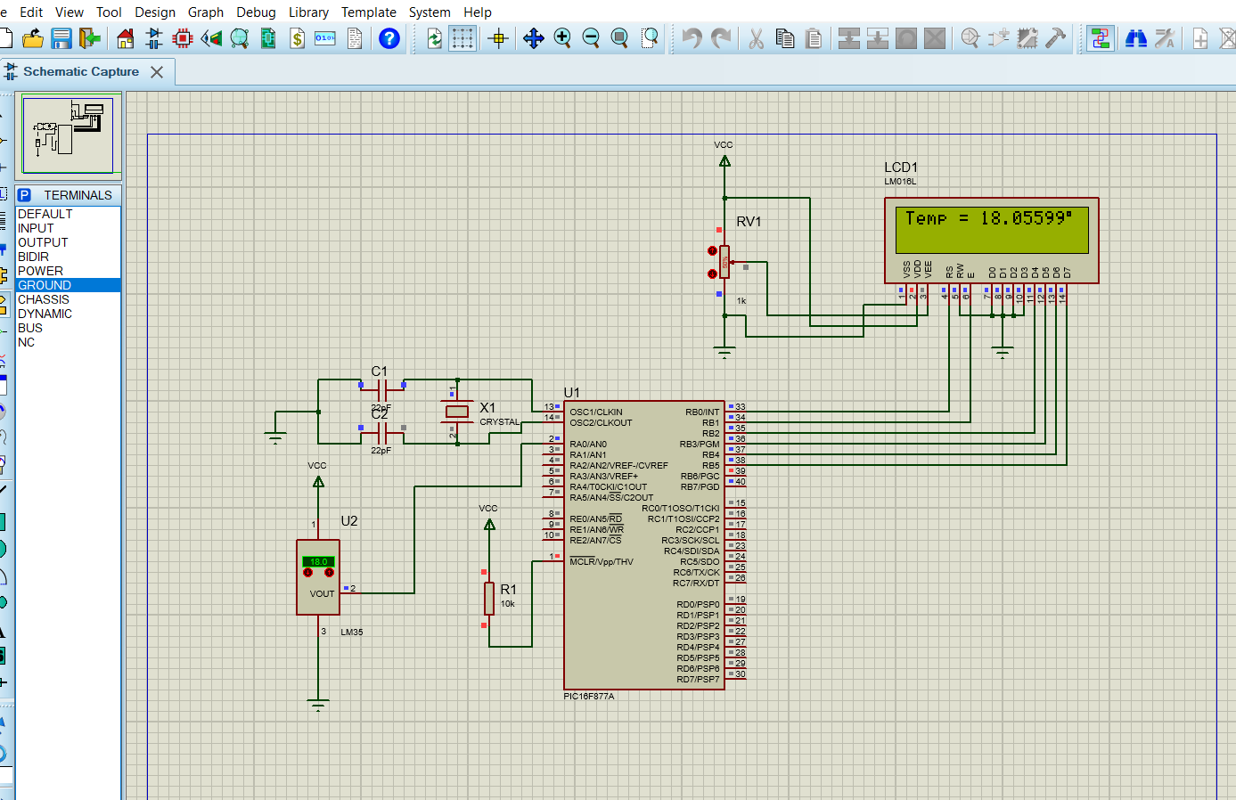

**Fig: LAB-5-LM35-Temperature-Sensor-Interfacing**

**CODE:**

sbit LCD_RS at RB0_bit;

sbit LCD_EN at RB1_bit;

sbit LCD_D4 at RB2_bit;

sbit LCD_D5 at RB3_bit;

sbit LCD_D6 at RB4_bit;

sbit LCD_D7 at RB5_bit;

sbit LCD_RS_DIRECTION at TRISB0_bit;

sbit LCD_EN_DIRECTION at TRISB1_bit;

sbit LCD_D4_DIRECTION at TRISB2_bit;

sbit LCD_D5_DIRECTION at TRISB3_bit;

sbit LCD_D6_DIRECTION at TRISB4_bit;

sbit LCD_D7_DIRECTION at TRISB5_bit;

char display[16]="";

void main()

{

unsigned int result;

float volt,temp;

trisb=0x00;

trisa=0xff;

adcon1=0x80;

lcd_init();

lcd_cmd(_lcd_clear);

lcd_cmd(_LCD_CURSOR_OFF);

while(1)

{

result = adc_read(0);

volt=result*4.88;

temp=volt/10;

lcd_out(1,1,"Temp = ");

floattostr(temp,display);

lcd_out_cp(display);

lcd_chr(1,16,223); //print at pos(row=1,col=13) "°" =223 =0xdf

lcd_out_cp(" C"); //celcius

}

}

**Circuit Diagram:**

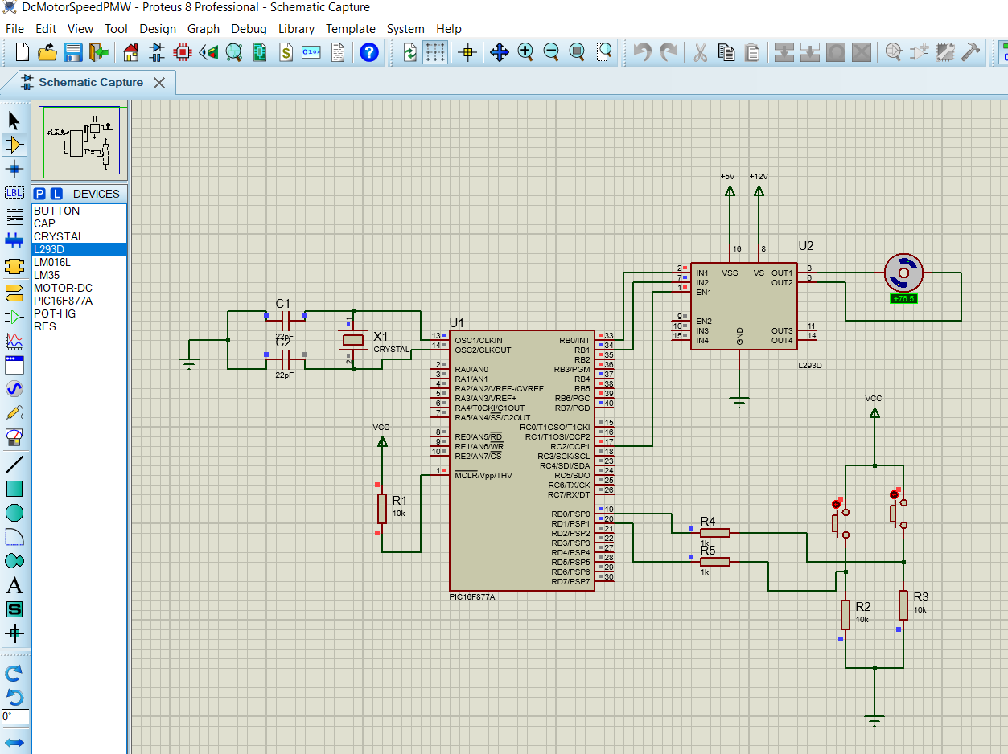

**Fig: DC Motor Speed Control PWM**

**CODE:**

void main(){

short duty = 0;

TRISD = 0xFF;

TRISB = 0x00;

PORTB.F0=0xff;

PORTB.F1=0x00;

PWM1_Init(1000);

PWM1_Start();

PWM1_Set_Duty(duty);

while (1) {

if (RD0_bit && duty<250) {

Delay_ms(100);

if (RD0_bit && duty<250) {

duty = duty + 10;

PWM1_Set_Duty(duty);

}

}

if (RD1_bit && duty >0) {

Delay_ms(100);

if (RD1_bit && duty >0) {

duty = duty - 10;

PWM1_Set_Duty(duty);

}

}

Delay_ms(10);

}

}

**Circuit Diagram:**

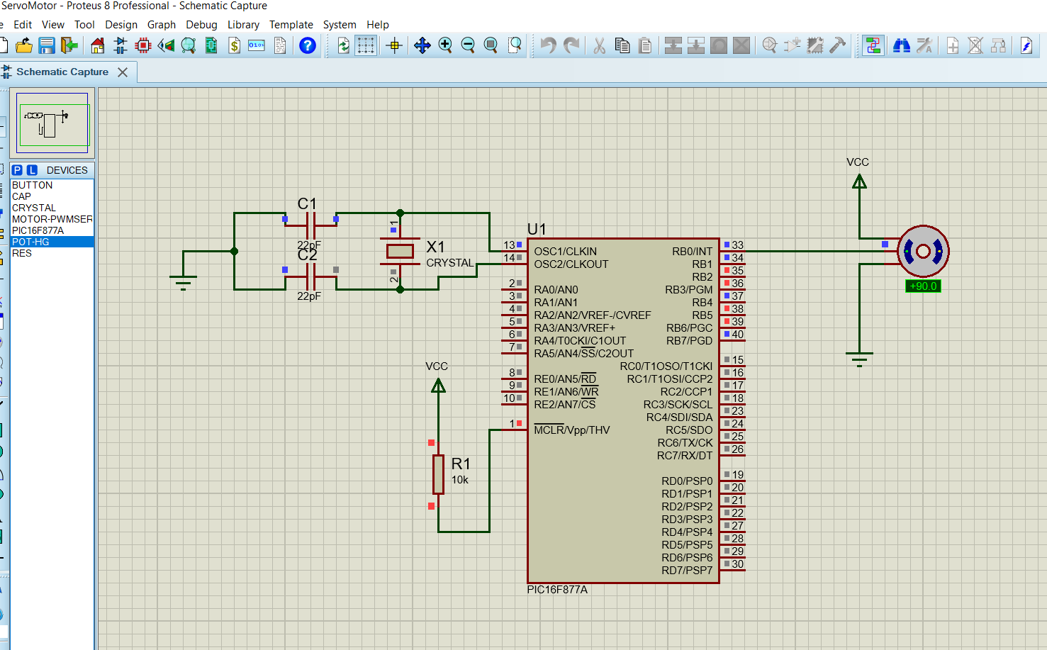

**Fig: Interfacing Servo Motor with PIC Microcontroller**

**CODE:**

void servoRotate0()

{

unsigned int i;

for(i=0;i<50;i++)

{

PORTB.F0 = 1;

Delay_us(800);

PORTB.F0 = 0;

Delay_us(19200);

}

}

void servoRotate90()

{

unsigned int i;

for(i=0;i<50;i++)

{

PORTB.F0 = 1;

Delay_us(1500);

PORTB.F0 = 0;

Delay_us(18500);

}

}

void servoRotate180()

{

unsigned int i;

for(i=0;i<50;i++)

{

PORTB.F0 = 1;

Delay_us(2200);

PORTB.F0 = 0;

Delay_us(17800);

}

}

void main()

{

TRISB = 0;

do

{

servoRotate0();

Delay_ms(2000);

servoRotate90();

Delay_ms(2000);

servoRotate180();

}

while(1);

}

**Circuit Diagram:**

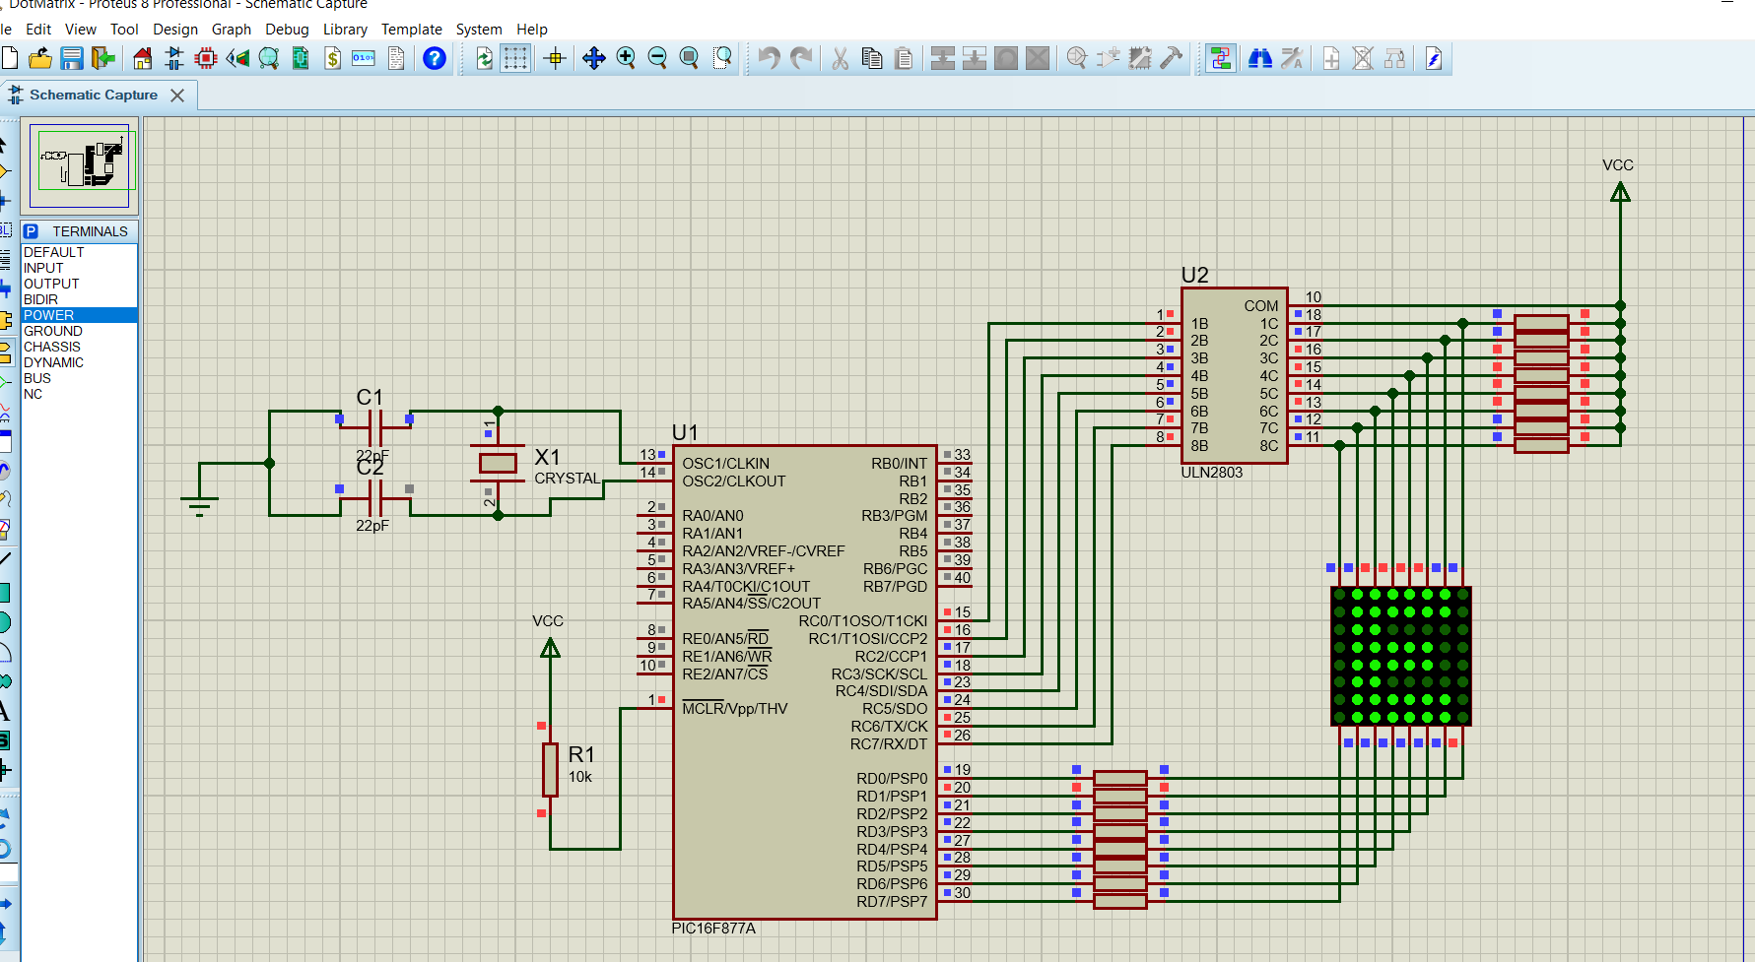

**Fig: Dot Matrix Display Interfacing**

**CODE:**

void MSDelay(unsigned char Time)

{

unsigned char y,z;

for(y=0;y<Time;y++)

for(z=0;z<20;z++);

}

void main()

{

TRISC = 0x00;

TRISD = 0x00;

while(1)

{

PORTD = 0x80;

PORTC = 0x00;

MSDelay(10);

PORTD = 0x40;

PORTC = 0xff;

MSDelay(10);

PORTD = 0x20;

PORTC = 0xff;

MSDelay(10);

PORTD = 0x10;

PORTC = 0xdb;

MSDelay(10);

PORTD = 0x08;

PORTC = 0xdb;

MSDelay(10);

PORTD = 0x04;

PORTC = 0xdb;

MSDelay(10);

PORTD = 0x02;

PORTC = 0xc3;

MSDelay(10);

PORTD = 0x01;

PORTC = 0x00;

MSDelay(10);

}

}

**Circuit Diagram:**

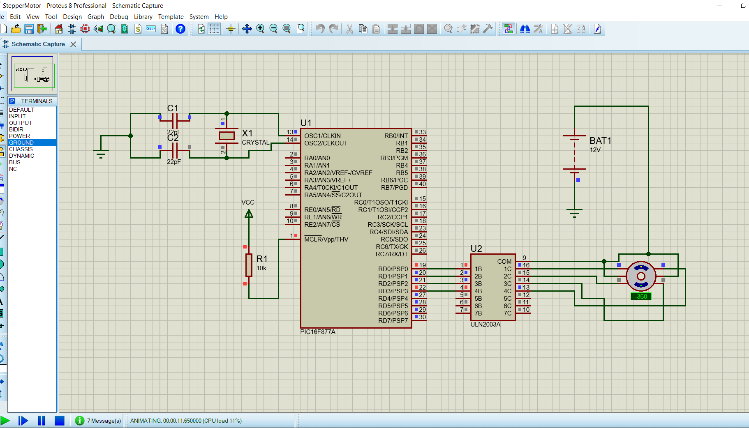

**Fig: Stepper Motor Interfacing**

**CODE:**

void main()

{

TRISD = 0b0000000;

PORTD = 0b1111111;

do

{

PORTD = 0b00000011;

Delay_ms(500);

PORTD = 0b00000110;

Delay_ms(500);

PORTD = 0b00001100;

Delay_ms(500);

PORTD = 0b00001001;

Delay_ms(500);

}

while(1);

}